Test Case: tc002_SPX_Dev5_Crear_Requisicion_Spot_Con_FAD_Tipo_Cobro_CC
Step 1 - Enter username and password and click to button Enter : Credentials Entered
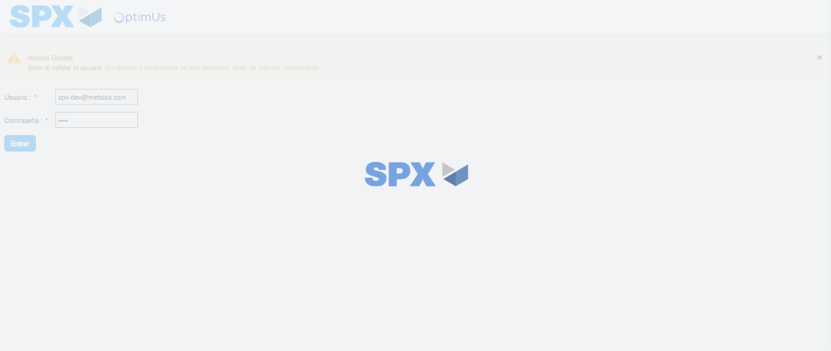Image file-name: QC_Testing-tc002_SPX_Dev5_Crear_Requisicion_Spot_Con_FAD_Tipo_Cobro_CC-1782314264407

Step 2 - Select to UEN and Access to Spot Buy Requisitions : UEN Correctly selected and Correct access
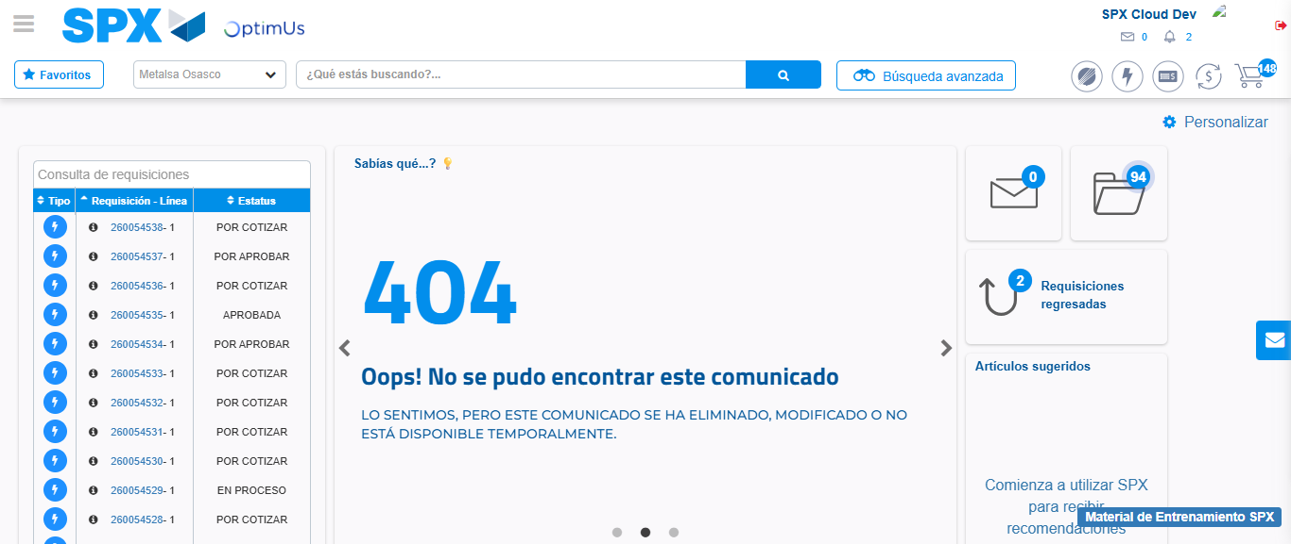Image file-name: QC_Testing-tc002_SPX_Dev5_Crear_Requisicion_Spot_Con_FAD_Tipo_Cobro_CC-1782314319065

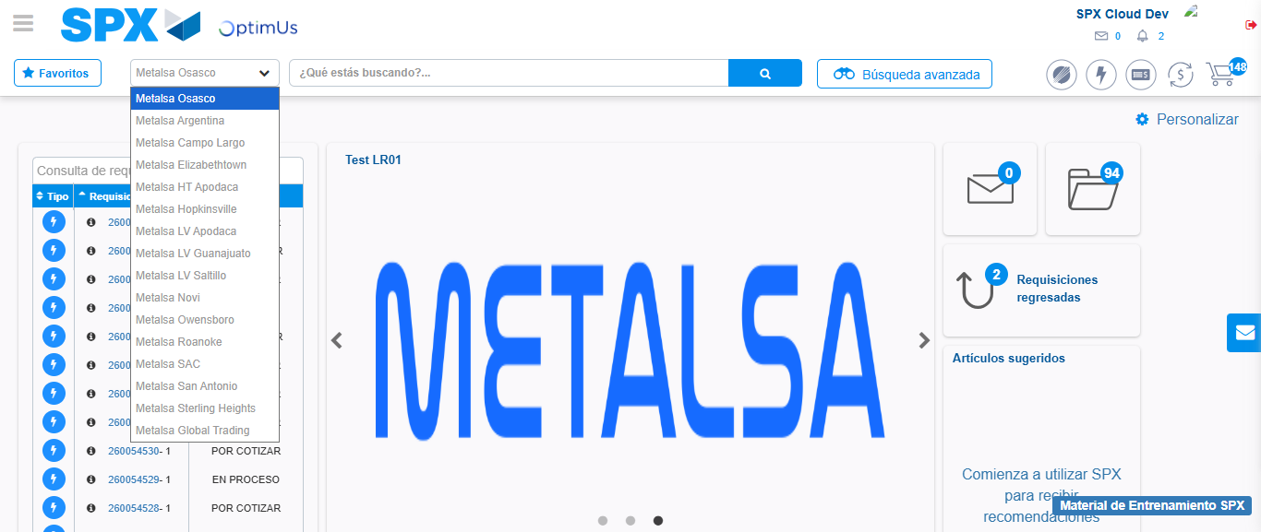Image file-name: QC_Testing-tc002_SPX_Dev5_Crear_Requisicion_Spot_Con_FAD_Tipo_Cobro_CC-1782314321878

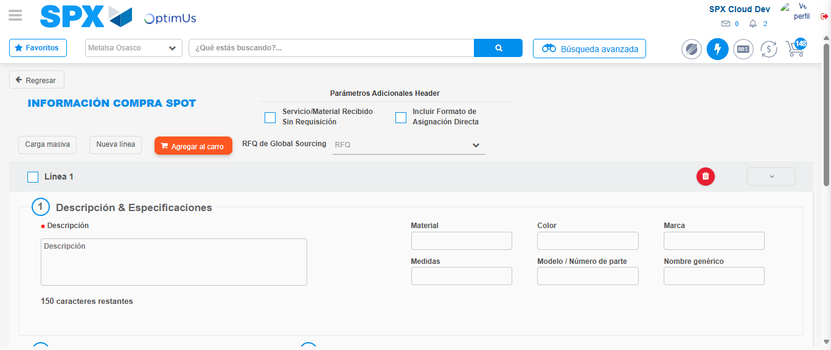Image file-name: QC_Testing-tc002_SPX_Dev5_Crear_Requisicion_Spot_Con_FAD_Tipo_Cobro_CC-1782314331298

Step 3 - Add FAD to Requisition: FAD Successfully Added
Image file-name: QC_Testing-tc002_SPX_Dev5_Crear_Requisicion_Spot_Con_FAD_Tipo_Cobro_CC-1782314331628

Image file-name: QC_Testing-tc002_SPX_Dev5_Crear_Requisicion_Spot_Con_FAD_Tipo_Cobro_CC-1782314331892

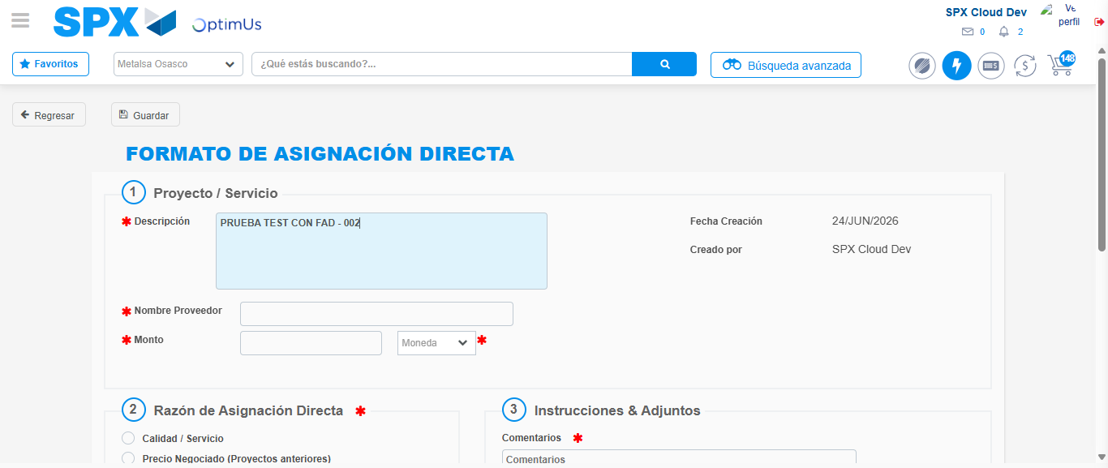Image file-name: QC_Testing-tc002_SPX_Dev5_Crear_Requisicion_Spot_Con_FAD_Tipo_Cobro_CC-1782314335222

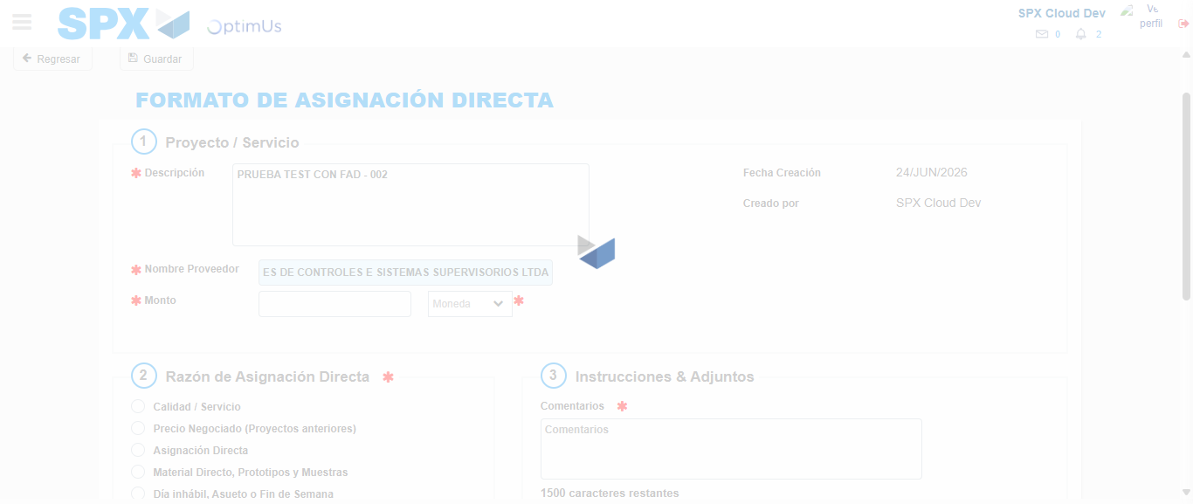Image file-name: QC_Testing-tc002_SPX_Dev5_Crear_Requisicion_Spot_Con_FAD_Tipo_Cobro_CC-1782314346415

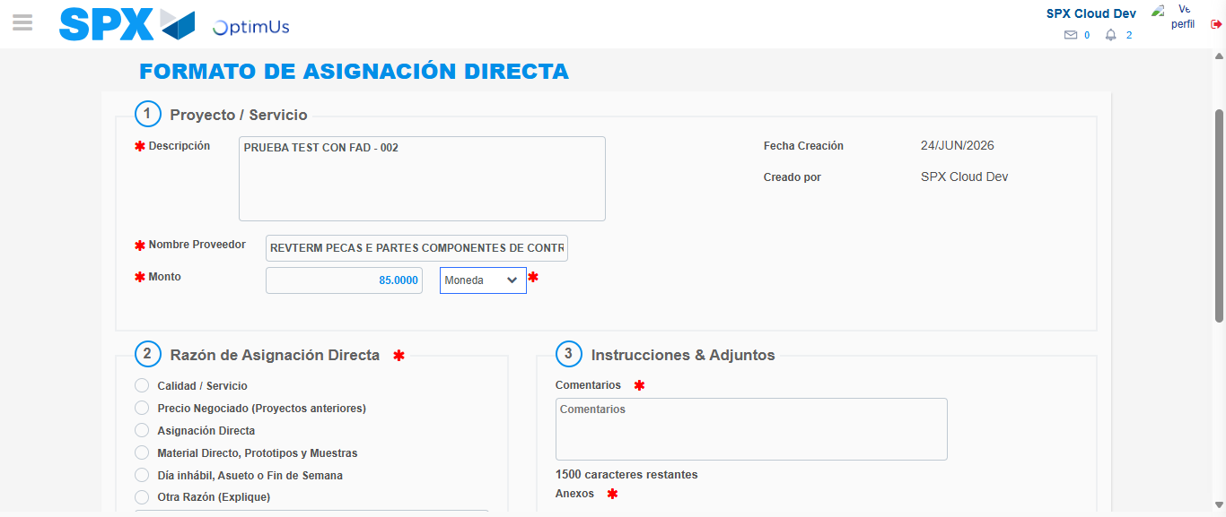Image file-name: QC_Testing-tc002_SPX_Dev5_Crear_Requisicion_Spot_Con_FAD_Tipo_Cobro_CC-1782314347000

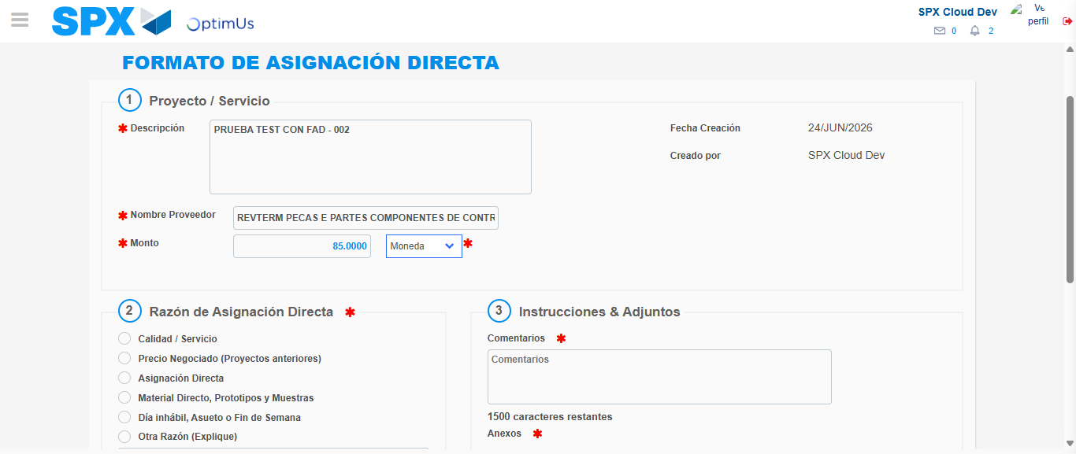Image file-name: QC_Testing-tc002_SPX_Dev5_Crear_Requisicion_Spot_Con_FAD_Tipo_Cobro_CC-1782314347255

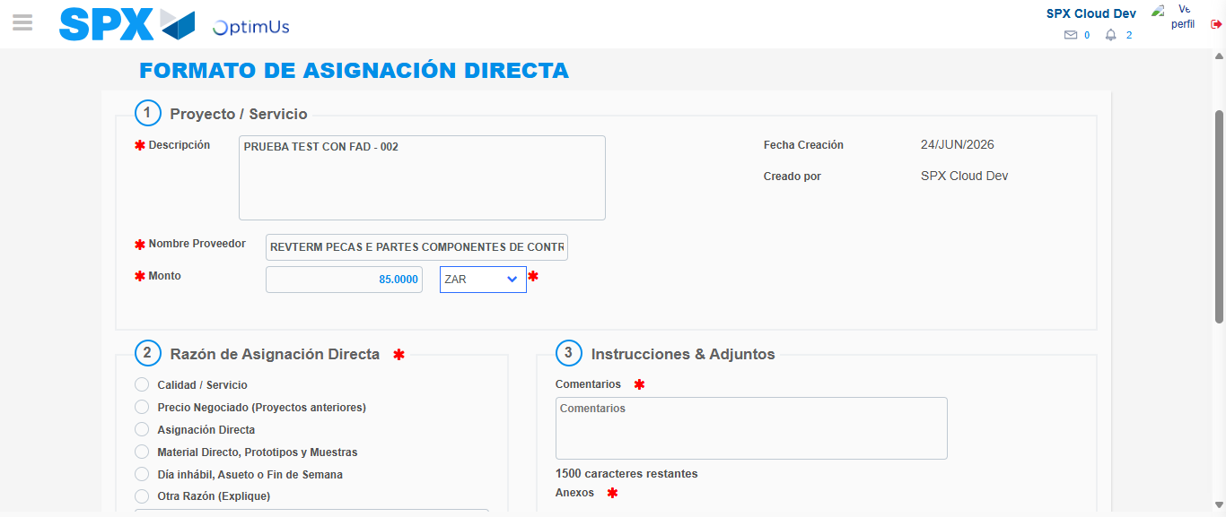Image file-name: QC_Testing-tc002_SPX_Dev5_Crear_Requisicion_Spot_Con_FAD_Tipo_Cobro_CC-1782314347751

Image file-name: QC_Testing-tc002_SPX_Dev5_Crear_Requisicion_Spot_Con_FAD_Tipo_Cobro_CC-1782314348002

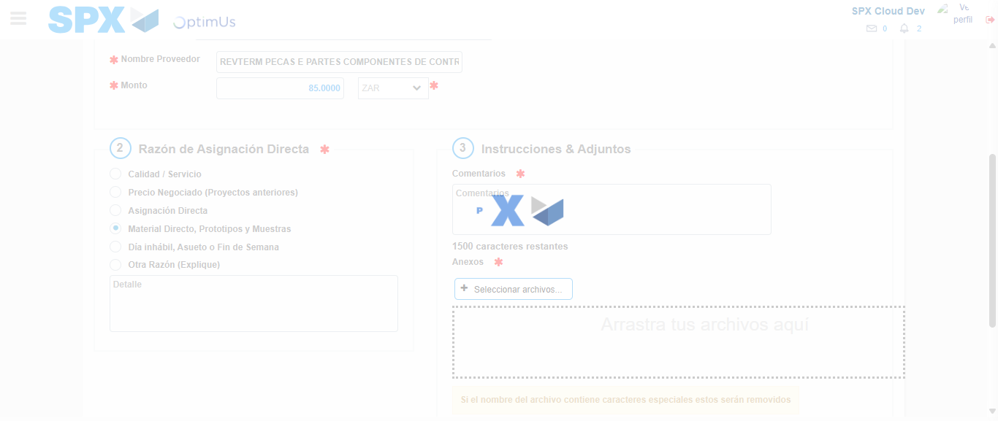Image file-name: QC_Testing-tc002_SPX_Dev5_Crear_Requisicion_Spot_Con_FAD_Tipo_Cobro_CC-1782314348992

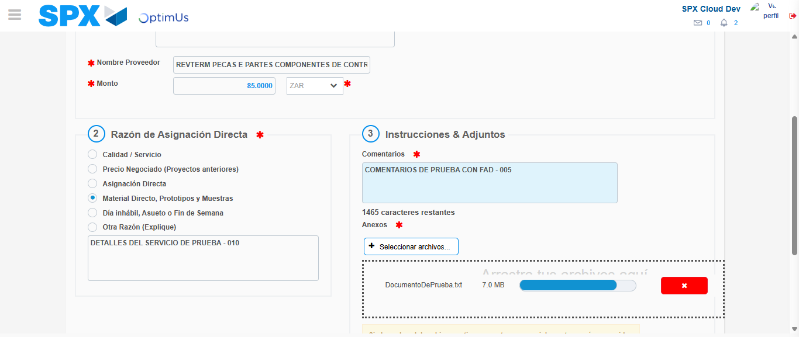Image file-name: QC_Testing-tc002_SPX_Dev5_Crear_Requisicion_Spot_Con_FAD_Tipo_Cobro_CC-1782314360133

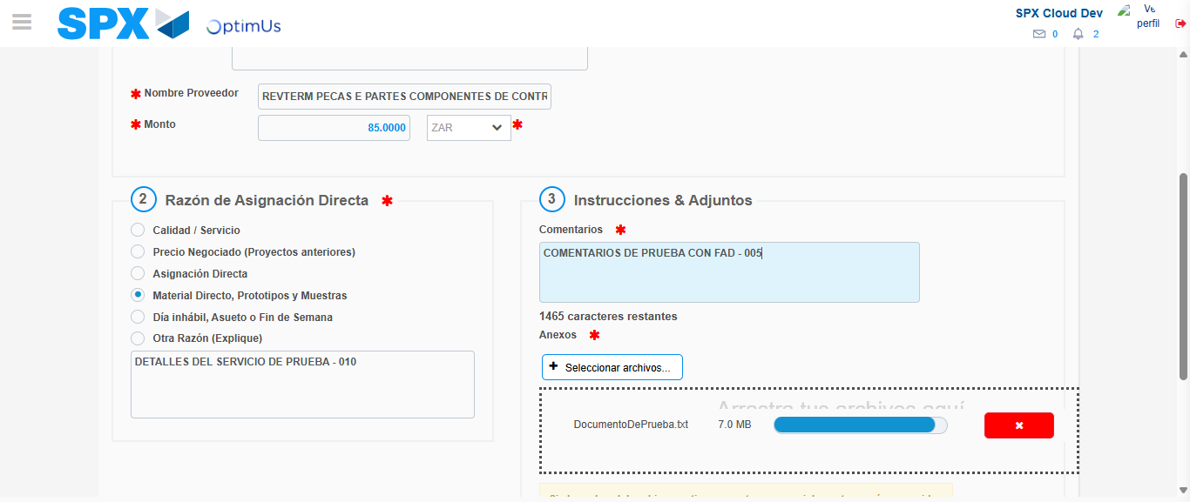Image file-name: QC_Testing-tc002_SPX_Dev5_Crear_Requisicion_Spot_Con_FAD_Tipo_Cobro_CC-1782314361315

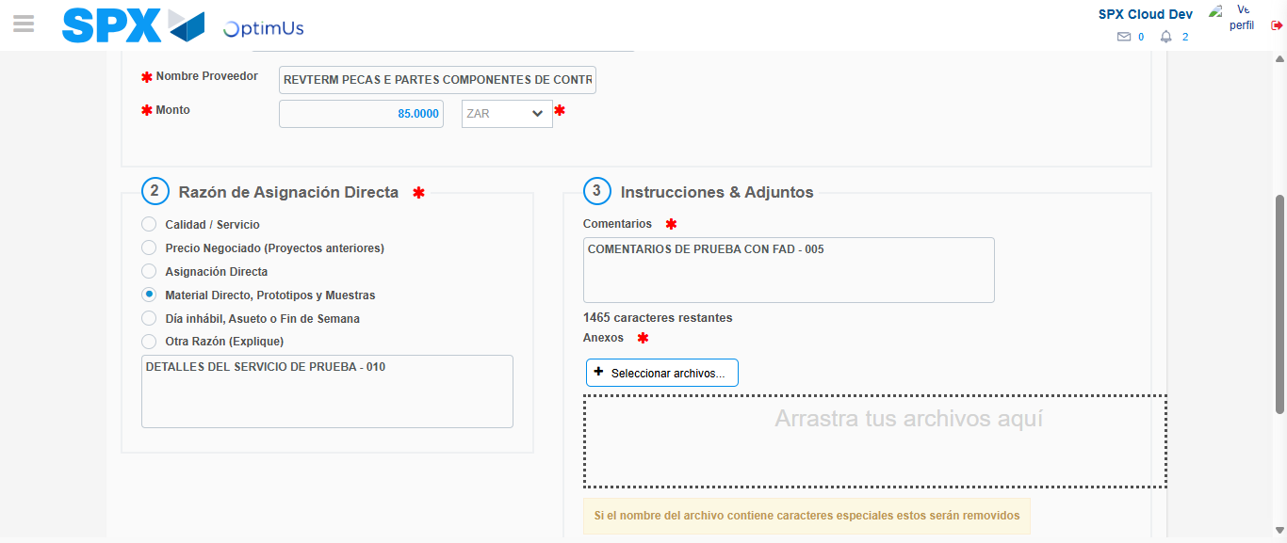Image file-name: QC_Testing-tc002_SPX_Dev5_Crear_Requisicion_Spot_Con_FAD_Tipo_Cobro_CC-1782314363218

Image file-name: QC_Testing-tc002_SPX_Dev5_Crear_Requisicion_Spot_Con_FAD_Tipo_Cobro_CC-1782314363514

Step 4 - Data Capture Spot Buy Requisition: Data captured correctly
Image file-name: QC_Testing-tc002_SPX_Dev5_Crear_Requisicion_Spot_Con_FAD_Tipo_Cobro_CC-1782314331628

Image file-name: QC_Testing-tc002_SPX_Dev5_Crear_Requisicion_Spot_Con_FAD_Tipo_Cobro_CC-1782314331892

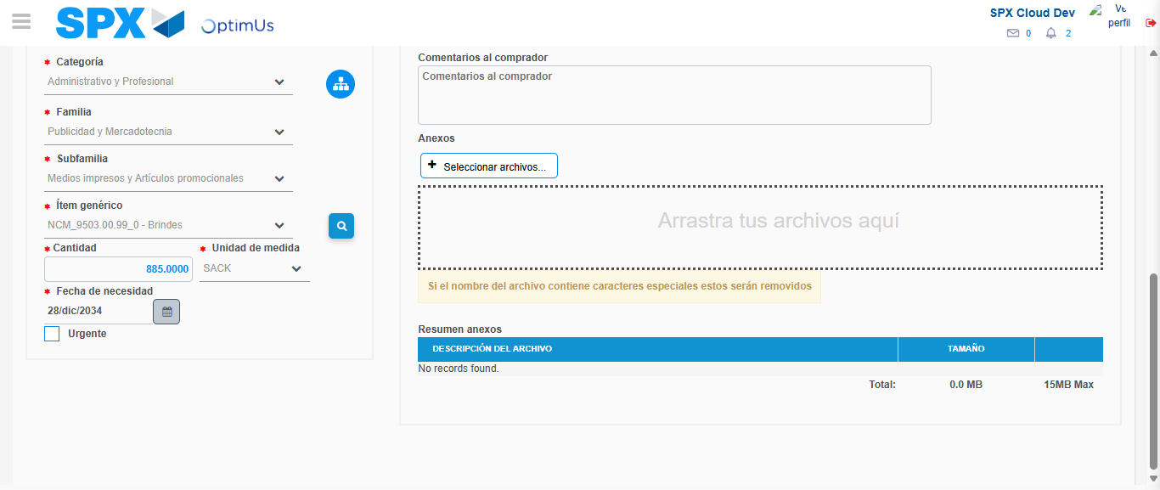Image file-name: QC_Testing-tc002_SPX_Dev5_Crear_Requisicion_Spot_Con_FAD_Tipo_Cobro_CC-1782314380576

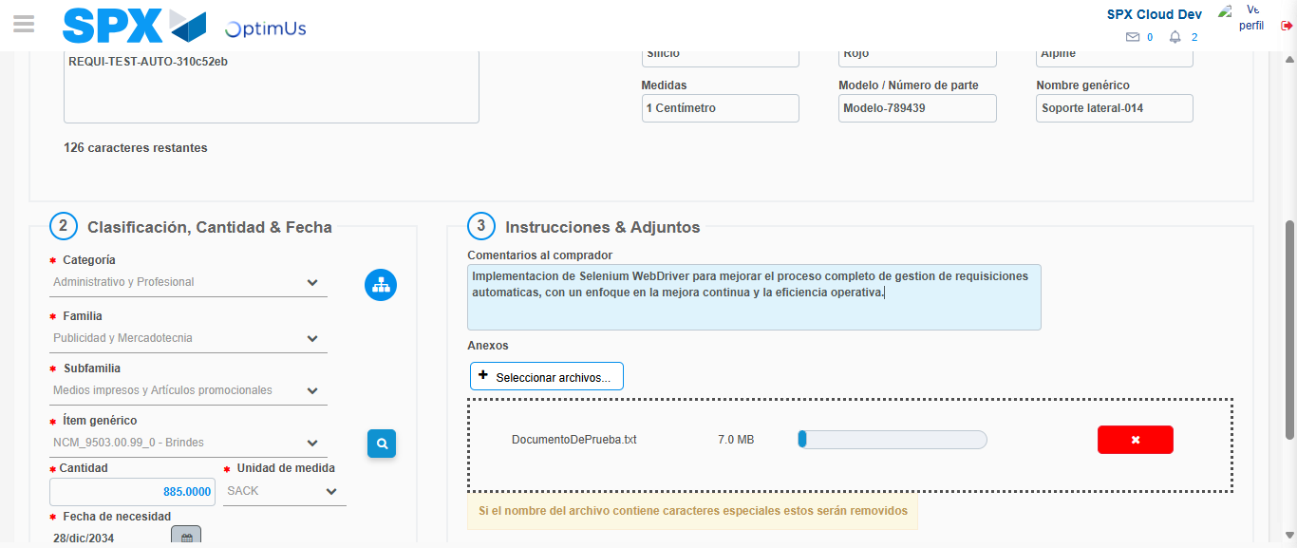Image file-name: QC_Testing-tc002_SPX_Dev5_Crear_Requisicion_Spot_Con_FAD_Tipo_Cobro_CC-1782314381473

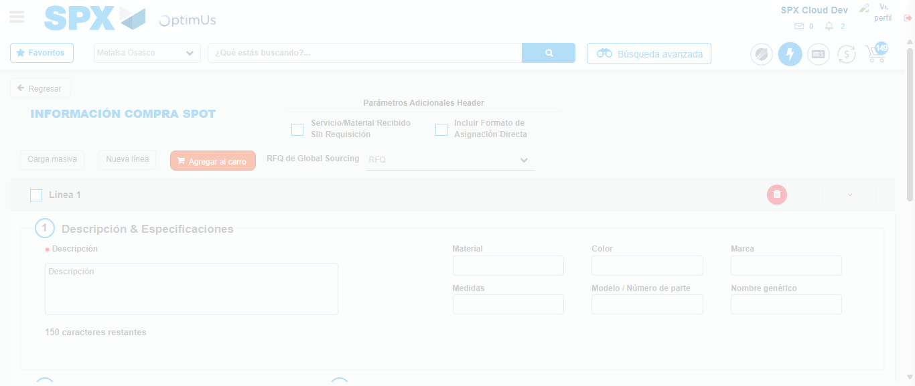Image file-name: QC_Testing-tc002_SPX_Dev5_Crear_Requisicion_Spot_Con_FAD_Tipo_Cobro_CC-1782314389398

Step 8 - Return to Main Page SPX : Return to Main Page SPX
Image file-name: QC_Testing-tc002_SPX_Dev5_Crear_Requisicion_Spot_Con_FAD_Tipo_Cobro_CC-1782314319065

Image file-name: QC_Testing-tc002_SPX_Dev5_Crear_Requisicion_Spot_Con_FAD_Tipo_Cobro_CC-1782314321878

Image file-name: QC_Testing-tc002_SPX_Dev5_Crear_Requisicion_Spot_Con_FAD_Tipo_Cobro_CC-1782314331298

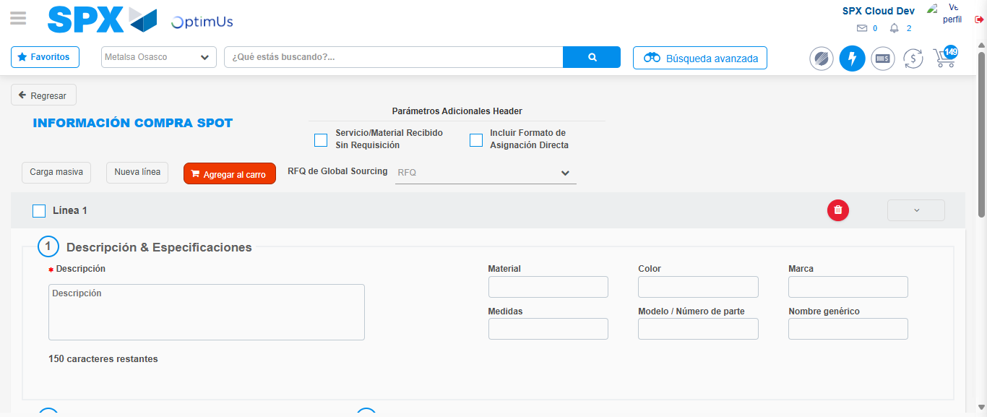Image file-name: QC_Testing-tc002_SPX_Dev5_Crear_Requisicion_Spot_Con_FAD_Tipo_Cobro_CC-1782314391734

Image file-name: QC_Testing-tc002_SPX_Dev5_Crear_Requisicion_Spot_Con_FAD_Tipo_Cobro_CC-1782314391962

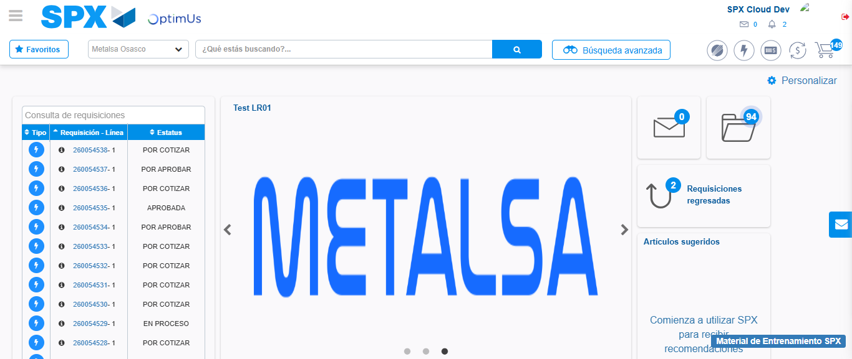Image file-name: QC_Testing-tc002_SPX_Dev5_Crear_Requisicion_Spot_Con_FAD_Tipo_Cobro_CC-1782314413366

Step 9 - Log Out : Log Out SPX
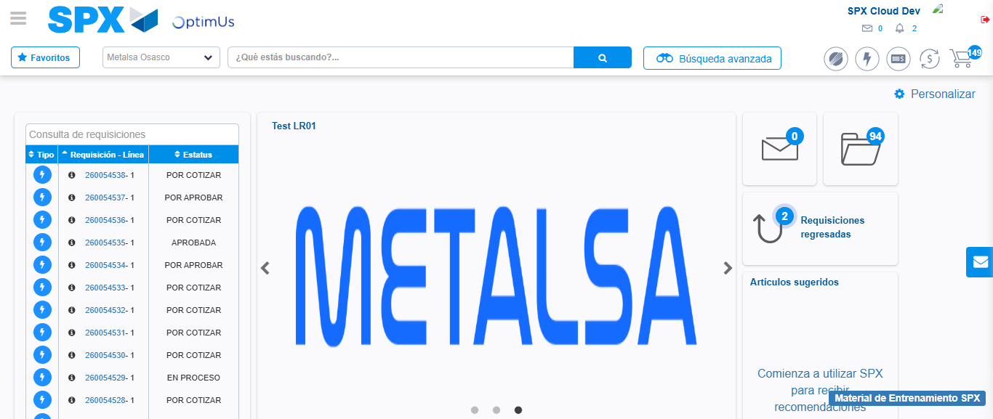Image file-name: QC_Testing-tc002_SPX_Dev5_Crear_Requisicion_Spot_Con_FAD_Tipo_Cobro_CC-1782314413732

